MA 322 Scientific Computing
Lab Assignment – 4
Pavan Kumar A
210123043

(1)
Final Solution: [1.77767192, 1.42396060, 1.23747112]
Residue: 2.4379e-11
Exact Solution: [1.77767192, 1.42396060, 1.23747112]
Error: 5.4168e-12

Iteration Table:
Iteration | Iterate | Error
0 | [1.000000,1.000000,1.000000] | 1.388462
1 | [2.189326,1.598475,1.393901] | 0.389754
2 | [1.850590,1.444251,1.278224] | 0.082876
3 | [1.780161,1.424436,1.239292] | 0.003117
4 | [1.777675,1.423961,1.237474] | 0.000004
5 | [1.777672,1.423961,1.237471] | 0.000000
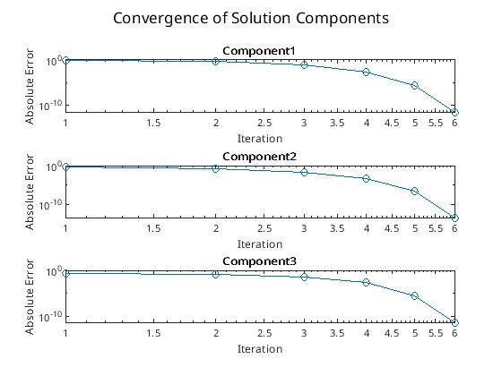
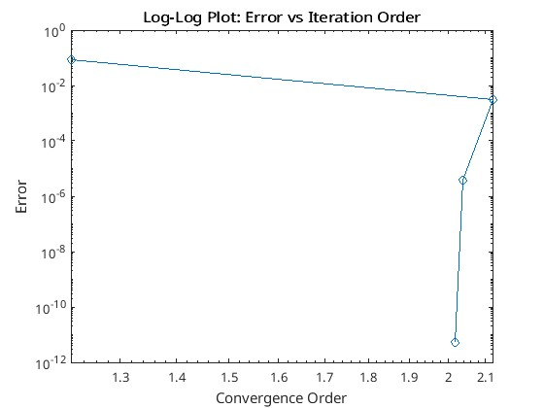

(2)
(a)
Final Solution: [0.33333333, 0.50000000]
Residue: 1.0187
Exact Solution: [0.54166667, 1.25000000]
Error: 0.7784

Iteration Table:

Iteration | Iterate | Error
0 | [0.000000,1.000000] | 0.600925
1 | [0.333333,0.500000] | 0.778398
2 | [0.541667,1.250000] | 0.282502
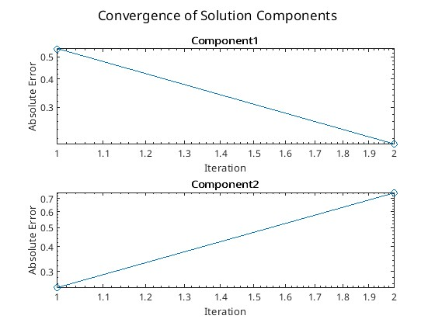
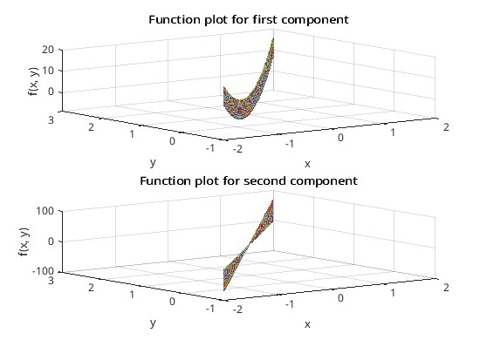

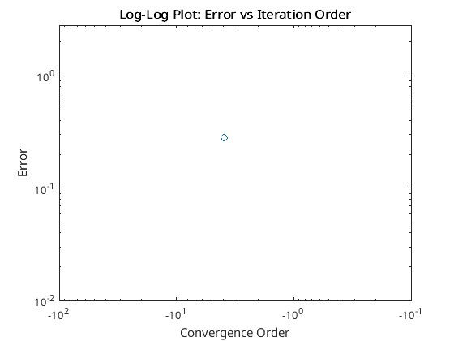

(b)
Final Solution: [-0.29317801, 1.17263436]
Residue: 9.0538e-05
Exact Solution: [-0.29316269, 1.17265982]
Error: 2.971e-05

Iteration Table:

Iteration | Iterate | Error
0 | [-1.000000,4.000000] | 2.048726
1 | [-0.504703,2.012047] | 0.715594
2 | [-0.374867,1.308330] | 0.151608
3 | [-0.301307,1.175764] | 0.008711
4 | [-0.293178,1.172634] | 0.000030
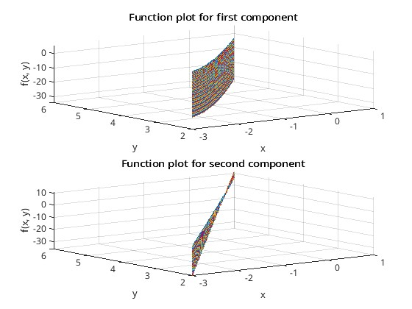
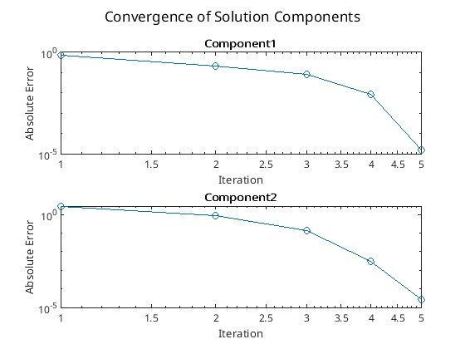

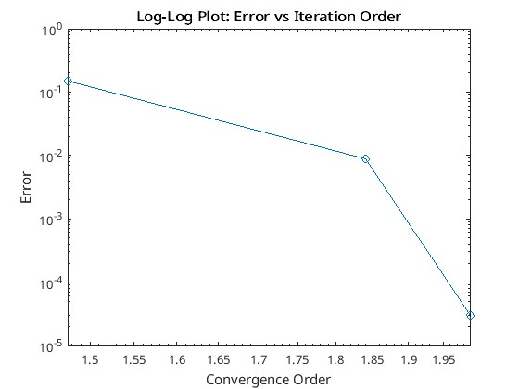

(3)
Converged in 4 iterations.
Final Solution: [0.49814468, -0.19960590, -0.52882598]
Residue: 8.8233e-11
Exact Solution: [0.49814468, -0.19960590, -0.52882598]
Error: 7.5767e-12

Iteration Table:

Iteration | Iterate | Error
0 | [0.000000,0.000000,0.000000] | 0.747532
1 | [0.500000,-0.186142,-0.523599] | 0.014561
2 | [0.498158,-0.199607,-0.528826] | 0.000013
3 | [0.498145,-0.199606,-0.528826] | 0.000000

